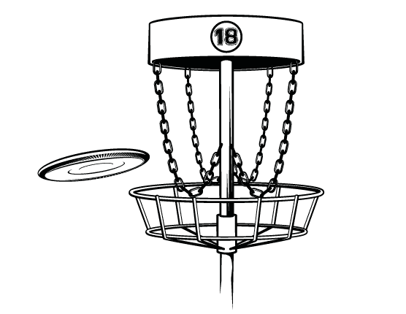C:\STOCKLAYOUTS\CURRENT PROJECTS\FN99801-PL\FN99801-IMG08.emfC:\STOCKLAYOUTS\CURRENT PROJECTS\FN99801-PL\FN99801-IMG08.emfC:\STOCKLAYOUTS\CURRENT PROJECTS\FN99801-PL\FN99801-IMG06.emf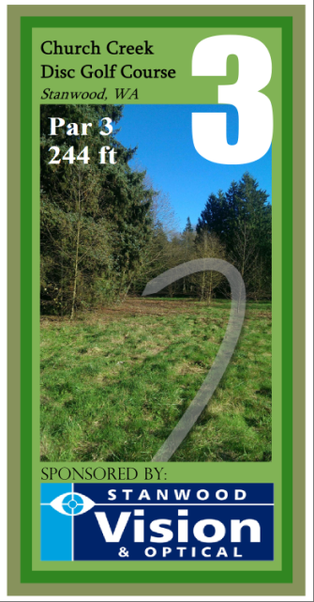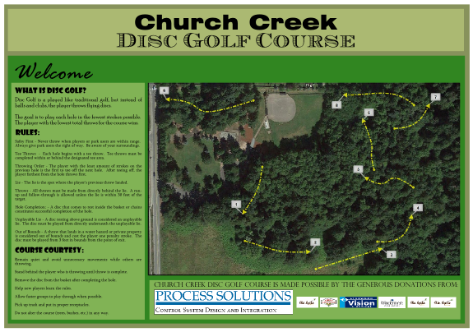

“your new course will provide a low-cost, healthful, enjoyable activity for people of all ages”

-Innova Disc Golf

In order to make the Church Creek Disc Golf Course the best course possible, we are asking for your support.

The financial goal for construction has already been met and the course will begin installation in March 2015.

Your contribution today will go towards landscaping, tree trimming, and ground cover to enhance the playability of course.

Now is the time to seize the opportunity to show community support and gain timeless recognition in the park.

Community Support

272nd St NW

Stanwood, WA 98292

www.chuchcreekdiscgolf.weebly.com

Church Creek Disc Golf

**Church Creek Park**

Disc Golf Course

**Contact a Representative Today:**

**Erik Bade (360) 224-2634**

***Course Planner***

**Hans Hendrickson (360) 461-9885**

***Course Advisor***

**Dalton VanHook (206) 719-5121 *Group Representative***

Sponsorship

Your Support will be Recognized

A $500 tax-deductable donation to the City of Stanwood will show the community that your business is behind positive activities in the City of Stanwood.

It’s relatively inexpensive compared to other sports amenities and once installed, will take very little to maintain.

Please help support the course and give community members of all ages a great way to share our park.

Donations can be made to the City of Stanwood. Please specify that the funds are going to the Church Creek Disc Golf Course.

Please send us an email if you have any questions:

churchcreekdiscgolf@gmail.com

Make a Donation

As a thank you for your support, one hole on the course will be dedicated to you or your business. Your logo will be included on one tee sign as well as added to the main course sign.

What is Disc Golf ?

It’s golf…with discs. It can be played with a normal frisbee® but most players utilize specialized discs for drives, approaches and putts.

It retains the structure and fun of traditional golf at a fraction of the price. And because the discs don’t need level ground for a quality course, it can be played virtually anywhere.

**Church Creek Park**

Disc Golf Course